3GPP TSG RAN WG1 #125 R1-2604132
Dalian, China, May 18th ~ 22nd, 2026

Source: OPPO
Title: Discussion on 6G ISAC scenarios and evaluations
Agenda Item: 10.8.1
Document for: Discussion and Decision

Introduction
There were some agreements for the evaluation use cases and some parameters assumption agreed in RAN1 #124bis meeting.
Working assumption:
For Rel-20 6G ISAC performance evaluation,
- evaluate object detection and/or tracking for the following sensing targets/objects: UAV, human, vehicle, AGV
- discuss further on evaluation on communication assistance
Agreement:
For Rel-20 6G sensing performance evaluation of object detection and/or tracking, the following cases/combinations are considered as baseline cases/combinations.
Sensing target | Indoor or outdoor | Scenario | Carrier frequency
UAV | Outdoor | UMa-AV, SMa | 4 GHz, ~7 GHz, 30 GHz (for UMa-AV only)
Human | Outdoor | UMa | 4 GHz, ~7 GHz, 30 GHz
 | Indoor | Indoor Hotspot | 4 GHz, ~7 GHz, 30 GHz
Vehicle | Outdoor | Urban Grid, Highway | 4 GHz, ~7 GHz, 30 GHz (for Urban Grid only)
AGV | Indoor | Indoor factory (SH) | 4 GHz, ~7 GHz, 30 GHz
- Note: sensing mode(s) for each row will be discussed
- Other cases/combinations can also be evaluated, reported and collected from companies.
Note: In this agreement, no intention to de-prioritize other scenarios or carrier frequencies.
Agreement:
Companies are encouraged to bring input to the sensing mode related evaluation assumptions in next meeting, using the following table as starting point. The values in current table are example values based on the input and discussion in RAN1#125.
Note: This is not intended to specify all sensing modes.
Note2: This does not mean any sensing mode is applicable to any scenario/use case.
Note3: Other parameters/values for each sensing mode can also be discussed.
This contribution gives our views on 6G ISAC evaluations.

Detection/tracking moving objects

Sensing modes
The sensing modes for each use case are discussed in this section. There are six sensing modes defined in TR38.901. These ISAC scenarios and sensing modes could be used as the starting points for ISAC study in 6G. For all sensing scenarios, the involvement of a UE into a sensing mode, e.g., TRP-UE bi-static, could help sensing by flexibly choosing a good location where the impact of environment to sensing, e.g., the NLOS condition, is mitigated. For each target type, the corresponding sensing scenario, applicable deployment scenario and suggested sensing modes for evaluation are given in the following proposal, where
- TRP-UE bi-static mode is applicable to all sensing scenarios, as we think it is the most basic sensing mode in 6G ISAC, due to its low resource overhead and less interactions with communication (e.g., no need to impact UL power control and UL timing advance).
- TRP-TRP bi-static mode can be applicable to ISAC-UAV due to its outstanding LOS probability on TRP-UAV links. On the other hand, such advantage on LOS probability is not strong in outdoor scenarios where the target is grounded. In addition, TRP-TRP bi-static mode may have limited indoor use given there can be just one TRP in one indoor sensing area.
- TRP mono-static mode is applicable to ISAC-UAV evaluations, as in 5G ISAC
- UE-UE bi-static mode can be applicable to two indoor scenarios: ISAC-human (indoor) and ISAC-AGV, and to two outdoor scenarios: ISAC-human (outdoor) and ISAC-Automotive. The advantage of UE-UE bi-static sensing is its flexibility STX/SRX deployment for high chance of LOS target channel.
- UE-TRP bi-static mode can be applicable to indoor scenarios, where the limited indoor sensing area does not need many STX UE’s to individually transmit sensing signals which consume quite amount of RS overheads.
Proposal 1: The following RAN1 #124b agreement is to be updated with sensing modes for evaluation purpose.
Sensing target | Indoor or outdoor | Scenario | Carrier frequency | Sensing modes for evaluation
UAV | Outdoor | UMa-AV, SMa | 4 GHz, ~7 GHz, 30 GHz (for UMa-AV only) | TRP-UE bi-static, TRP-TRP bi-static, TRP mono-static
Human | Outdoor | UMa | 4 GHz, ~7 GHz, 30 GHz | TRP-UE bi-static, UE-UE bi-static
 | Indoor | Indoor Hotspot | 4 GHz, ~7 GHz, 30 GHz | TRP-UE bi-static, UE-TRP bi-static, UE-UE bi-static
Vehicle | Outdoor | Urban Grid, Highway | 4 GHz, ~7 GHz, 30 GHz (for Urban Grid only) | TRP-UE bi-static, UE-UE bi-static
AGV | Indoor | Indoor factory (SH) | 4 GHz, ~7 GHz, 30 GHz | TRP-UE bi-static, UE-TRP bi-static, UE-UE bi-static
In our view, the 6G sensing mode should not go beyond 6G duplexing study. For TRP-TRP bi-static mode, within the same slot where a SRX TRP receives the sensing signal, the SRX TRP may be allowed to transmit a communication signal. Then at least for evaluation purpose, time-overlapping Tx/Rx for SRX-TRP is preferred. In this case, the evaluation for TRP-TRP bi-static could focus on sensing procedure, independently with communication. A SRX-UE in UE-UE bi-static mode should operate with non-overlapping Tx/Rx only.
Proposal 2: For 6G sensing modes,
- If TRP-TRP bi-static mode is considered in the 6G study, it should be clarified whether the SRX TRP follows a restriction of TDM Tx/Rx or allows resource-overlapping Tx/Rx, where Tx is for communication purpose and Rx is for sensing purpose.
- A SRX-UE in UE-UE bi-static mode should operate with non-overlapping Tx/Rx only.

Evaluation assumptions
SLS considers an entire system with multiple STX/SRX nodes and multiple targets by taking into account the details of target channel such as the target RCS, and can show the area-wide performance for sensing including missing/false-alarm probabilities and sensing result accuracy. On the other hand, LLS focus on the performance of point-to-point case to evaluate the physical layer transmission performance under specific channel conditions, without modeling the large scale fading. In our view, it is good enough for RAN1 to use system level simulation to evaluate the sensing performance, as RAN did in 5G ISAC, and to study the impacts from different sensing signal designs. The necessity of running link level simulations for the study in agenda 10.8.1 is not strong. The link level simulation can be considered in agenda 10.8.3 for the waveform study.
Proposal 3: The evaluation work in agenda 10.8.1 focuses on system level simulation.
STX transmission power
Traditionally, the transmission powers of TRP and UE and the signal bandwidth in the evaluations are assumed to be frequency dependent. In RAN1 6G EVM study, it is agreed that for 6G communication evaluation purpose the total BS Tx power in SLS is given in the table below.
Total transmit power per BS | Indoor Hotspot | Dense Urban | Urban Macro | Sub-urban macro | Rural
Around 700MHz | NA | Macro BS:  - Option1: 44 dBm per 20 MHz  - Option2: 49 dBm per 20 MHz  Micro BS:  33 dBm per 20 MHz | Macro BS:  49 dBm per 20 MHz  Micro BS:  33 dBm per 20 MHz | Macro BS:  49 dBm per 20 MHz
Around 2GHz | 24 dBm per 20 MHz | Macro BS:  - Option1: 44 dBm per 20 MHz  - Option2: 46 dBm per 20 MHz  Micro BS:  33 dBm per 20 MHz | Macro BS:  - Option1: 49 dBm per 20 MHz  - Option2: 46 dBm per 20 MHz  Micro BS:  33 dBm per 20 MHz
Around 4GHz |  | Macro BS:  - Option1: 44 dBm per 20 MHz  Micro BS:  33 dBm per 20 MHz | Macro BS:  - Option1: 49 dBm per 20 MHz  - Option2: 44 dBm per 20 MHz  - Option3: 46 dBm per 20 MHz  Micro BS:  33 dBm per 20 MHz
Around 7GHz |  | Macro BS:  - Option1: 44 dBm per 20 MHz  - Option2: 43 dBm per 20 MHz  Micro BS:  33 dBm per 20 MHz | Macro BS:  - Option1: 49 dBm per 20 MHz  - Option2: 43 dBm per 20 MHz  - Option3: 46 dBm per 20 MHz  Micro BS:  33 dBm per 20 MHz
Around 15GHz | 23dBm per 20MHz | Macro BS:  43dBm per 20MHz  Micro BS:  33 dBm per 20 MHz | - Macro BS:  43dBm per 20MHz  - Micro BS:  33 dBm per 20 MHz | Macro BS:  43dBm per 20MHz | NA
Note: For evaluation purpose, BS Tx power scales up with bandwidth proportionally under the limitation of the maximum BS Tx power is 56dBm for outdoor and 33dBm for indoor for the above carrier frequencies.

Note: The values defined in option1 refer to the Report ITU-R M. [IMT-2030. EVAL].
Around 30GHz | - Option1: 23 dBm per 20 MHz  - Option2: 16dBm per 20MHz. | Micro BS:  33 dBm per 20 MHz | Micro BS:  33 dBm per 20 MHz | Macro BS:  33 dBm per 20 MHz | NA
Note: For evaluation purpose, for around 30GHz, BS Tx power scales up with bandwidth proportionally under the limitation of EIRP 75dBm.
It makes sense to choose BS TX power for sensing evaluation based on above RAN1 assumptions for communication evaluation. Meanwhile, RAN1 6G EVM study also agreed the following for UE power classes:
UE power class | Indoor Hotspot | Dense Urban / Urban Macro / Sub-urban macro | Rural
Around 700MHz | NA | 23dBm
Around 2 ~ 7 GHz | 23dBm, 26dBm, 29dBm
Around 15GHz | 23dB, 26dBm, 29dBm |  | NA
Around 30GHz | For non-CPE: peak EIRP≥23dBm, EIRP≤43dBm  For CPE only (Note 1): peak EIRP≥35dBm, EIRP≤55dBm |  | NA
For CPE only and for <30GHz, the transmission power of 35dBm is assumed.
NOTE1: It is up to company to report the simulated transmission power confined within the defined peak EIRP range.
It is suggested that the UE Tx power in ISAC SLS follows 6G EVM agreements on UE power assumption for communication.
RAN1 discussion on 6G EVM concluded quit a few BS/UE antenna configurations for communication-purpose SLS, as given in Appendix A and Appendix B. The set should be narrow-down for the evaluation of sensing. If simultaneously Tx/Rx for STX-TRP is assumed, the maximum Tx power determination should consider the antenna isolation to avoid self-interference.
Proposal 4: RAN1 considers the following assumptions as starting points for sensing SLS.
- BS Tx power scales up with bandwidth by X dBm per 20MHz and is upper-bounded by Y dBm, where X and Y depend on carrier frequency, deployment scenario and BS types.
 | InH / InF | Dense Urban | Urban Macro | Sub-urban Macro / Rural
<=7GHz | X=24, Y=33 | Macro BS: X=44, Y=56  Micro BS: X=33, Y=56 | Macro BS: X=49, Y=56  Micro BS: X=33, Y=56 | X=49, Y=56
Around 15GHz | X=23, Y=33 | Macro BS: X=44, Y=56  Micro BS: X=33, Y=56 |  | X=43, Y=56
Around 30GHz | X=23, FFS Y | X=33, FFS Y
- UE Tx power follows RAN1 6G EVM conclusions, for both handheld UE and CPE.
- BS/UE antenna configurations are selected from 6G EVM discussion outcome.
Maximum velocity and location distribution of UAV target
For the other SLS assumptions, especially the ones about deployments and sensing targets, the existing assumptions in TR38.901 could be a good reference with some exceptions. For example, as described in out accompanying contribution [3], the maximum UAV speed of 180km/h is not large enough to reflect the highest UAV velocity in nowadays civilian market, and a system behaving no problem with assumption of maximum 180km/h UAV speed may miss-detect an illegal high UAV speed as a legal speed. In addition, the 5G-ISAC evaluation assumes the UAV always flies above the antenna height (25m for Uma-AV), which actually contributes to hide the angle ambiguity issue from being identified. This should not happen again in 6G study. So it is proposed to reuse the UAV height range Option A given in 38.901.
Proposal 5: For ISAC-UAV scenario,
- The horizontal velocity of a UAV is assumed between 0 and 320km/h.
- The UAV location distribution on vertical plane is uniform between 1.5m and 300m.
Number of UEs in TRP-UE/UE-TRP sensing modes
For the TRP-UE/UE-TRP sensing modes, the LOS probability can be the key influence factor for the sensing performance. In order to compensate the potentially weak LOS probability, multiple UE’s in the roles of either SRX or STX could be needed to effectively construct a multi-static sensing based on multiple bi-static sensing pairing. To verify this analysis, we compare the LOS probability of TRP-UE bi-static and TRP monostatic sensing mode in the scenarios of UMa, UMa-AV and InH, respectively, with the following evaluation steps.
- Step 1: As illustrated in Fig.1, one TRP is placed at the cell center and K candidate positions are randomly and uniformly selected within the sensing area, where each candidate position is designated for deploying one sensing target (ST). K=50 is adopted in our simulation. Note that distinct cell boundaries are not well defined for the InH deployment scenario. Following the TRP association principle, we only select a limited small region with the TRP located at the center, and perform uniformly random target dropping within this area.
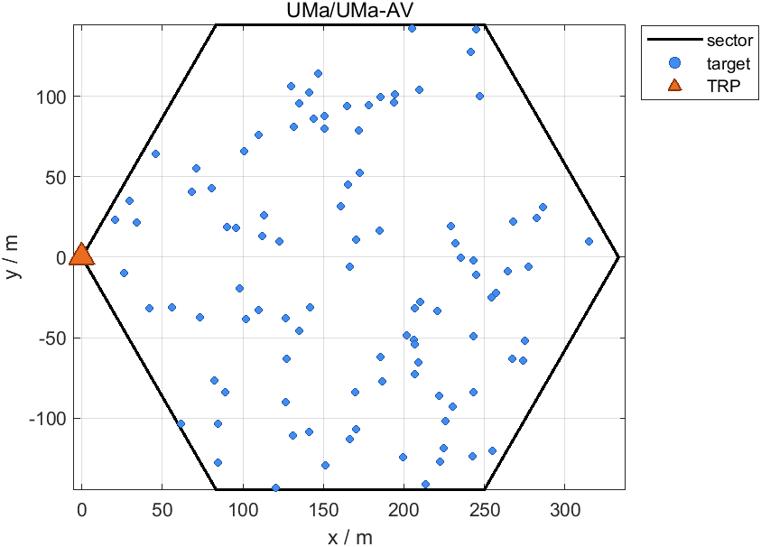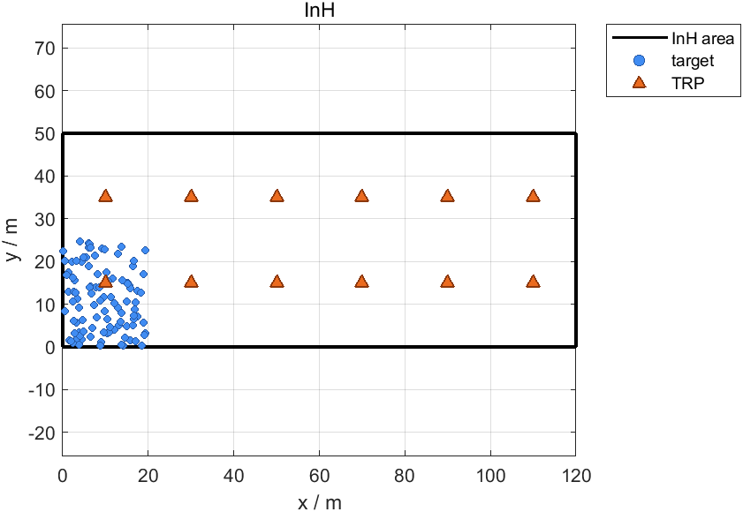
- (b)
Fig.1 TRP and ST locations for LOS target channel evaluation
- Step 2: Perform multiple simulation drops. Each drop observes N UEs (as SRX’s) uniformly and randomly deployed within the geographical area of the cell.
- Step 3: For each of the K sensing target positions ST_{k}​, compute two LOS probabilities based on the LOS formula defined in 38.901:
- $P_{LOS,1}$: The probability for the link TRP-ST_{k}​ is LOS, which corresponds to the LOS probability in TRP mono-static mode.
- $P_{LOS,2}$: The probability for both the TRP-ST_{k}​ link and the ST_{k}-UE link for at least one UE are LOS, which corresponds to a LOS+LOS target channel for target ST_{k} in TRP-UE bi-static mode.
- Step 4: Generate the statistical results, including CDF of $P_{LOS,1}$ and CDF of $P_{LOS,2}$, as shown in Fig 2.
It can be observed from Fig 2 that, although TRP mono-static mode can experience better LOS probability than TRP-UE bistatic mode, the gap between the LOS probabilities in the target channel of these two sensing modes is reduced as the number of UEs increases. In fact, one of the benefits of TRP-UE/UE-TRP bistatic sensing modes is the flexibility in deploying a UE as either SRX or STX at a position that can deem to have a better chance of LOS link between the UE and the target.
Proposal 6: The UE dropping in TRP-UE bistatic mode and UE-TRP bistatic mode should be made in such a way that a sufficient number (e.g., >10) of UE’s are paired with a same TRP.
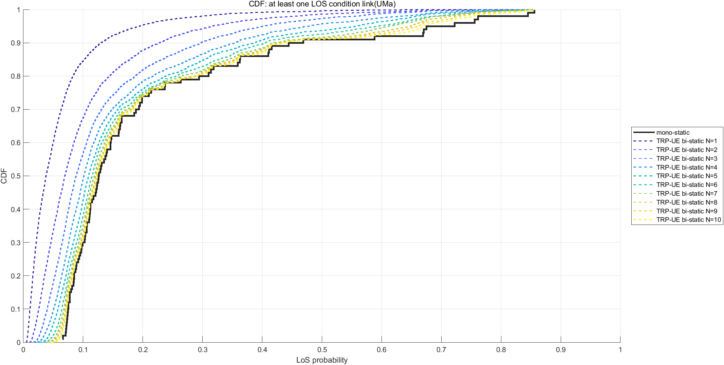
(a)
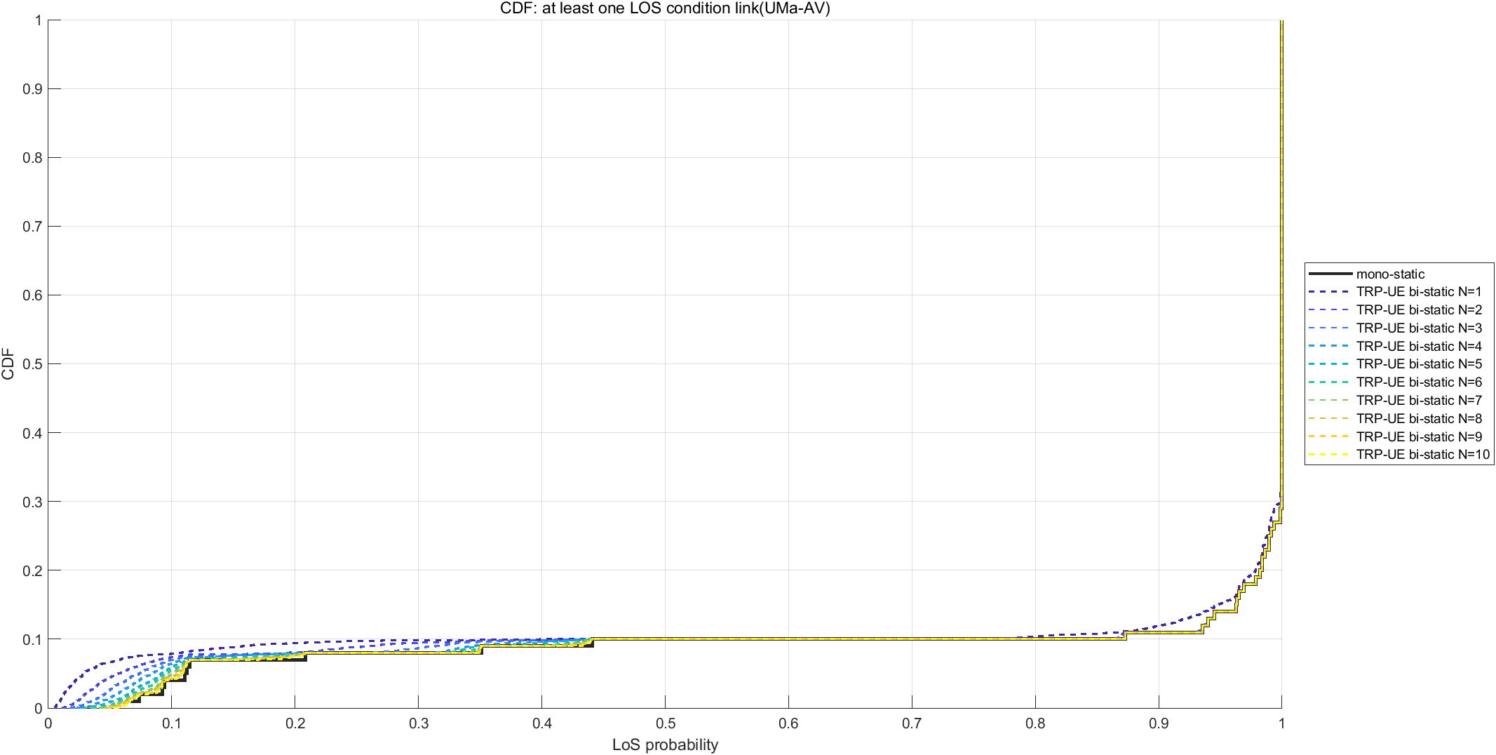
(b)
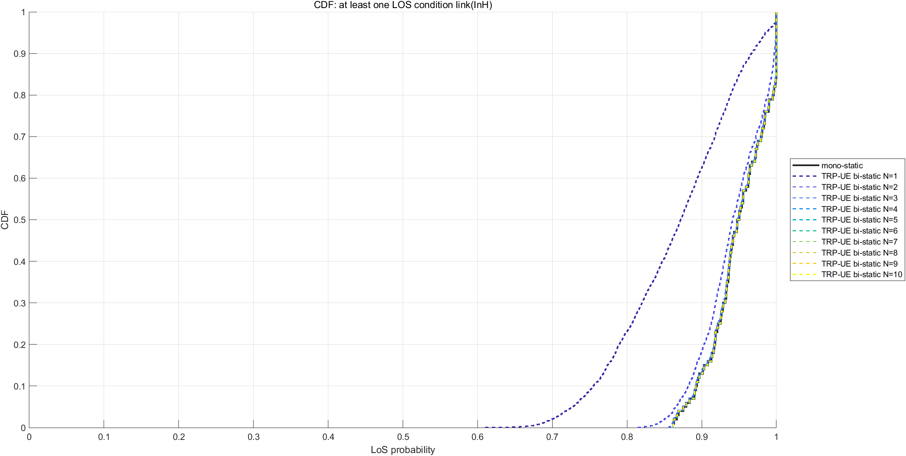
（c）
Fig.2 LOS probabilities of target channel in Uma/Uma-AV/InH
For STX/SRX selection, the bi-static sensing may have different criteria from mono-static sensing in 5G ISAC. In addition, the study involving with multi-static sensing may introduce additional considerations on the STX/SRX selection.
Proposal 7: RAN1 to study the STX/SRX selection criteria, taking into account bi-static sensing and multi-static sensing.
The number of targets per sensing area
The performance metric of miss detection makes it reasonable to have multiple targets in one simulation drop for reliable evaluation. However, an excessive number of targets will lead to prohibitive computation complexity and excessively long simulation runtime, which may become the main bottleneck for system-level evaluation. Meanwhile, the number of targets per sensing area may have a great impact to the type of fusion algorithm in sensing function that can be used for evaluation. For example, for a sensing area that has one STX, N SRX’s and K targets, assume each of N SRX’s detects all K targets as K Level-C points in the measurement report to SF. A brute-force fusion at SF may search over a total of up to ${\left(K!\right)}^{N-1}$ combinations of N reported points per each of K targets. Such complexity can easily go beyond what a typical SLS can handle and ban the brute-force fusion algorithm, unless K takes a small value such as 2 or 3.
In 5GA ISAC evaluation, 5 UAV targets per TRP was adopted for TRP mono-static sensing where the TRP can directly report Level-D measurement results to SF and the SF is not required to perform further fusion operation upon the reports from multiple TRP’s. Targeting technical feasibility verification of integrated sensing and communication, to configure more than 5 targets per sensing convex hull would introduce extremely high implementation complexity as well as severe mutual interference, and therefore is not preferable.
Proposal 8: The number of sensing targets per sensing area in the ISAC evaluation is set to
- 2 or 3, if fusion over measurements from multiple SRX’s is eventually performed at a node like SF; and
- 5, if fusion over measurements from multiple SRX’s is not performed.

Minimum distance between targets
The distance between targets imposes stringent requirements on sensing resolution and further puts high constraints on system bandwidth configuration. Take 100MHz BW as an example, the range resolution can be derived as $\frac{C}{2B}=1.5m$ and thereby it can be difficult to distinguish the targets with an inter-target distance of 1m.
Proposal 9: Evaluation assumptions on sensing signal bandwidth and the minimum inter-target distance should take into account the inter-relation in-between.
Our suggested values for the other parameters are given in the following tables.
Proposal 10: RAN1 to adopt deployment-related assumptions and target-related assumptions in the following Table for different sensing scenarios.
Table-1: Evaluation assumptions for different sensing scenarios
Parameters | ISAC-UAV | ISAC-Automotive | ISAC-Human (outdoor) | ISAC-Human (indoor) | ISAC-AGV
Deployment scenario | UMa-AV | Urban Grid (ISD=500m, BS height=25m) | UMa | Indoor open office | Indoor factory(SH)
Sectorization | Hexagonal grid, 7 sites, 3 sectors (with 30, 150, 270 degrees) per site |  |  | Option 1: Omni-directional  Option 2: 3 sectors with 30, 150, 270 degrees
BS noise figure | Around 7GHz and below: 5dB  Around 15GHz and above: 7dB
UE noise figure | Around 7GHz and below: 9dB  Around 15GHz and above: 10dB
Target type & modeling | UAV of small size | Vehicle (single scattering point) | Human (model 2) |  | AGV (single scattering point)
Component A of the RCS for each scattering point | -12.81 dBsm | 11.25 dBsm | -1.37 dBsm |  | -4.25 dBsm
Sensing target distribution | N=[2,5] targets;  Horizontal plane: uniformly distributed within one cell  Vertical plane: Uniform between 1.5m and 300m. | N=[2,5] targets;  Based on dropping in TR37.885 per urban grid. Details FFS (e.g., narrow down options) | N=[2,5] targets uniformly distributed within one cell. | N=[2,5] targets uniformly distributed within deployment area. | N=[2,5] uniformly distributed in the convex hull of the horizontal BS deployment
Sensing target 3D mobility | Horizontal velocity: uniform distribution between 0 and 320km/h.  Vertical velocity: 0km/h | Based on TR37.885 mobility for urban grid. Details FFS (e.g., narrow down options) | 3km/h |  | Fixed velocities {3, 10} km/h
Minimum 3D distances between pairs of STX/SRX and sensing target | 10 m | 6m (based on 2-lane 2-way street of width 20m. Refer to Figure A-1 in 37.885) | [1,4] m | [1,4] m | [1,4] m
Waveform | CP-OFDM

Performance metrics (or objectives)
The performance objectives studied in 5G ISAC for UAV use case could be considered as starting point for 6G sensing evaluation. The following outlines an extension of 5G performance objectives into 6G.
- Horizontal/vertical positioning accuracy is defined as the absolute differences between the estimated horizontal/vertical positions and the corresponding true positions of a sensing target.
- Velocity accuracy is defined as the absolute value of the difference between the estimated velocity and the corresponding true velocity of a sensing target, where the velocity can be either a radial velocity or a 3D velocity.
- Missed detection probability is defined as the conditional probability of not detecting the presence of a target when the target is actually present in the simulation area.
- False alarm probability Type 1 is defined for an evaluation without any true target being dropped in the whole simulation area. A Type-1 false alarm event refers to a simulation run in which at least one target of interest (note 5G ISAC says “object” here) is detected when no true target presents in the simulation area.
- False alarm probability Type 2 is defined for an evaluation with at least one true target being dropped in simulation area. A Type-2 false alarm event refers to a target of interest (note 5G ISAC says “object” here) being detected but in fact not associated with any true target, where the association rule needs to be clarified.
It is worthwhile to note that the false alarm probability agreed in RAN plenary SI states as following [ref. TR38.914], which is closer to the above definition of Type-2 FA probability. In addition, it uses “sensing target” for what is detected, instead of using “object” as in 5G ISAC definition.
false alarm probability is the associated probability that a sensing target is detected when no corresponding true sensing target is present.
Given the Type-1 FA probability did not offer more technical insights than Type-2 FA probability in 5G ISAC study, it is suggested to drop false alarm probability Type-1 in the 6G study.
Proposal 11: The following performance objectives can be used for 6G sensing study of object detection and tracking.
- Horizontal/vertical positioning accuracy, as defined in 5G ISAC;
- Velocity accuracy, where an extension of radio velocity to general bi-static mode is needed;
- Detection probability or equivalent miss probability, as defined in 5G ISAC;
- False alarm probability is defined as a probability of an event where a target of interest being detected but in fact not associated with any true target.
  - FFS the association rule
  - RAN1 drops false alarm probability Type-1 in 6G study.
For the radio velocity accuracy, the general radio velocity in a bi-static sensing geometry can be derived from equation (7.9.4-5) in TR38.901 as following, which takes radio velocity in a mono-static geometry as a special case.
$$v_{radio}=\left[{\hat{r}}_{rx,k,p,n^{'},m^{'}}^{T}\left(t\right){\bar{v}}_{rx}\left(t\right)+{\hat{r}}_{k,p,n^{'},m^{'}}^{T}\left(t\right){\bar{v}}_{k,p}\left(t\right)\right]+\left[{\hat{r}}_{tx,k,p,n,m}^{T}\left(t\right){\bar{v}}_{tx}\left(t\right)+{\hat{r}}_{k,p,n,m}^{T}{\left(t\right)\bar{v}}_{k,p}\left(t\right)\right]$$
The RAN1 #124b discussion assumed zero velocity for both STX and SRX, which results in a radio velocity as
$$v_{radio}=\left[{\hat{r}}_{k,p,n^{'},m^{'}}^{T}\left(t\right)+{\hat{r}}_{k,p,n,m}^{T}\left(t\right)\right]{\bar{v}}_{k,p}\left(t\right)=2\left|{\bar{v}}_{k,p}\left(t\right)\right|∙cos\left(\frac{β}{2}\right)cos\left(α\right)$$
where $β$ is the bistatic angle on the target side between incident ray and scattering ray of the path on which the Doppler is measured, and $α$ is the angle between the true velocity vector and the bisector vector associated with the bistatic angle $β$.
Proposal 12: RAN1 defines the radio velocity accuracy as the absolute value of the difference between an estimated radio velocity and the corresponding true radio velocity of a sensing target, where for both mono-static sensing and bi-static sensing,
- The estimated radio velocity is determined as $v_{radio}=f_{D}∙λ$, where $f_{D}$ is the Doppler shift measured from the sensing signal and $λ$ is the carrier wavelength.
- Under assumption of zero velocity of both STX and SRX, the true radio velocity is determined as $2v_{3D}cos\left(\frac{β}{2}\right)cosα$, where $v_{3D}$ is the true 3D velocity, $β$ is the bistatic angle on the ST side between incident ray and scattering ray of the path on which the Doppler is measured, and $α$ is the angle between the true velocity vector and the bisector vector within the bistatic angle $β$. For mono-static sensing, $β=0$.
In 5G ISAC evaluation, sensing overhead and CPI are treated as evaluation assumptions. However, these two parameters should be considered as parts of evaluation results, showing whether/how the different choices of values on these two parameters bring different sensing performance.
Proposal 13: The sensing overhead and CPI are considered as part of evaluation study objectives, instead of evaluation assumptions.

Conclusions
This contribution concludes with the following observations and proposals.
Proposal 1: The following RAN1 #124b agreement is to be updated with sensing modes for evaluation purpose.
Sensing target | Indoor or outdoor | Scenario | Carrier frequency | Sensing modes for evaluation
UAV | Outdoor | UMa-AV, SMa | 4 GHz, ~7 GHz, 30 GHz (for UMa-AV only) | TRP-UE bi-static, TRP-TRP bi-static, TRP mono-static
Human | Outdoor | UMa | 4 GHz, ~7 GHz, 30 GHz | TRP-UE bi-static, UE-UE bi-static
 | Indoor | Indoor Hotspot | 4 GHz, ~7 GHz, 30 GHz | TRP-UE bi-static, UE-TRP bi-static, UE-UE bi-static
Vehicle | Outdoor | Urban Grid, Highway | 4 GHz, ~7 GHz, 30 GHz (for Urban Grid only) | TRP-UE bi-static, UE-UE bi-static
AGV | Indoor | Indoor factory (SH) | 4 GHz, ~7 GHz, 30 GHz | TRP-UE bi-static, UE-TRP bi-static, UE-UE bi-static
Proposal 2: For 6G sensing modes,
- If TRP-TRP bi-static mode is considered in the 6G study, it should be clarified whether the SRX TRP follows a restriction of TDM Tx/Rx or allows resource-overlapping Tx/Rx, where Tx is for communication purpose and Rx is for sensing purpose.
- A SRX-UE in UE-UE bi-static mode should operate with non-overlapping Tx/Rx only.
Proposal 3: The evaluation work in agenda 10.8.1 focuses on system level simulation.
Proposal 4: RAN1 considers the following assumptions as starting points for sensing SLS.
- BS Tx power scales up with bandwidth by X dBm per 20MHz and is upper-bounded by Y dBm, where X and Y depend on carrier frequency, deployment scenario and BS types.
 | InH / InF | Dense Urban | Urban Macro | Sub-urban Macro / Rural
<=7GHz | X=24, Y=33 | Macro BS: X=44, Y=56  Micro BS: X=33, Y=56 | Macro BS: X=49, Y=56  Micro BS: X=33, Y=56 | X=49, Y=56
Around 15GHz | X=23, Y=33 | Macro BS: X=44, Y=56  Micro BS: X=33, Y=56 |  | X=43, Y=56
Around 30GHz | X=23, FFS Y | X=33, FFS Y
- UE Tx power follows RAN1 6G EVM conclusions, for both handheld UE and CPE.
- BS/UE antenna configurations are selected from 6G EVM discussion outcome.
Proposal 5: For ISAC-UAV scenario,
- The horizontal velocity of a UAV is assumed between 0 and 320km/h.
- The UAV location distribution on vertical plane is uniform between 1.5m and 300m.
Proposal 6: The UE dropping in TRP-UE bistatic mode and UE-TRP bistatic mode should be made in such a way that a sufficient number (e.g., >10) of UE’s are paired with a same TRP.
Proposal 7: RAN1 to study the STX/SRX selection criteria, taking into account bi-static sensing and multi-static sensing.
Proposal 8: The number of sensing targets per sensing area in the ISAC evaluation is set to
- 2 or 3, if fusion over measurements from multiple SRX’s is eventually performed at a node like SF; and
- 5, if fusion over measurements from multiple SRX’s is not performed.
Proposal 9: Evaluation assumptions on sensing signal bandwidth and the minimum inter-target distance should take into account the inter-relation in-between.
Proposal 10: RAN1 to adopt deployment-related assumptions and target-related assumptions in the following Table for different sensing scenarios.
Parameters | ISAC-UAV | ISAC-Automotive | ISAC-Human (outdoor) | ISAC-Human (indoor) | ISAC-AGV
Deployment scenario | UMa-AV | Urban Grid (ISD=500m, BS height=25m) | UMa | Indoor open office | Indoor factory(SH)
Sectorization | Hexagonal grid, 7 sites, 3 sectors (with 30, 150, 270 degrees) per site |  |  | Option 1: Omni-directional  Option 2: 3 sectors with 30, 150, 270 degrees
BS noise figure | Around 7GHz and below: 5dB  Around 15GHz and above: 7dB
UE noise figure | Around 7GHz and below: 9dB  Around 15GHz and above: 10dB
Target type & modeling | UAV of small size | Vehicle (single scattering point) | Human (model 2) |  | AGV (single scattering point)
Component A of the RCS for each scattering point | -12.81 dBsm | 11.25 dBsm | -1.37 dBsm |  | -4.25 dBsm
Sensing target distribution | N=[2,5] targets;  Horizontal plane: uniformly distributed within one cell  Vertical plane: Uniform between 1.5m and 300m. | N=[2,5] targets;  Based on dropping in TR37.885 per urban grid. Details FFS (e.g., narrow down options) | N=[2,5] targets uniformly distributed within one cell. | N=[2,5] targets uniformly distributed within deployment area. | N=[2,5] uniformly distributed in the convex hull of the horizontal BS deployment
Sensing target 3D mobility | Horizontal velocity: uniform distribution between 0 and 320km/h.  Vertical velocity: 0km/h | Based on TR37.885 mobility for urban grid. Details FFS (e.g., narrow down options) | 3km/h |  | Fixed velocities {3, 10} km/h
Minimum 3D distances between pairs of STX/SRX and sensing target | 10 m | 6m (based on 2-lane 2-way street of width 20m. Refer to Figure A-1 in 37.885) | [1,4] m | [1,4] m | [1,4] m
Waveform | CP-OFDM
Proposal 11: The following performance objectives can be used for 6G sensing study of object detection and tracking.
- Horizontal/vertical positioning accuracy, as defined in 5G ISAC;
- Velocity accuracy, where an extension of radio velocity to general bi-static mode is needed;
- Detection probability or equivalent miss probability, as defined in 5G ISAC;
- False alarm probability is defined as a probability of an event where a target of interest being detected but in fact not associated with any true target.
  - FFS the association rule
  - RAN1 drops false alarm probability Type-1 in 6G study.
Proposal 12: RAN1 defines the radio velocity accuracy as the absolute value of the difference between an estimated radio velocity and the corresponding true radio velocity of a sensing target, where for both mono-static sensing and bi-static sensing,
- The estimated radio velocity is determined as $v_{radio}=f_{D}∙λ$, where $f_{D}$ is the Doppler shift measured from the sensing signal and $λ$ is the carrier wavelength.
- Under assumption of zero velocity of both STX and SRX, the true radio velocity is determined as $2v_{3D}cos\left(\frac{β}{2}\right)cosα$, where $v_{3D}$ is the true 3D velocity, $β$ is the bistatic angle on the ST side between incident ray and scattering ray of the path on which the Doppler is measured, and $α$ is the angle between the true velocity vector and the bisector vector within the bistatic angle $β$. For mono-static sensing, $β=0$.
Proposal 13: The sensing overhead and CPI are considered as part of evaluation study objectives, instead of evaluation assumptions.

Reference
- RP-253876, Revised SID: Study on 6G Radio, NTT DOCOMO, CMCC, AT&T, Vodafone
- RP-260073, Study on 6G Scenarios and Requirements
- R1-2604133, Discussion on sensing detection and integration with communication, OPPO

Appendix A. RAN1 agreements on BS antenna modeling in 6G EVM discussion

For around 700MHz carrier frequency:
BS antenna modelling | Total number of antenna elements | Total number of TXRU | (M, N, P, Mg , Ng; Mp, Np) | (dH,dV)
Combination 1(Baseline) | 32 | 4 | (8, 2, 2, 1, 1; 1, 2) | (0.5, 0.5)λ
Combination 2 (Optional) | 64 | 8 | (8, 4, 2, 1, 1; 1, 4) | (0.5, 0.5)λ
Note: Other values/combinations are up to company to report

For around 2GHz carrier frequency:
BS antenna modelling | Total number of antenna elements | Total number of TXRU | (M, N, P, Mg , Ng; Mp, Np) | (dH,dV)
Indoor
Combination 1(Optional) | 8 | 4 | (2, 2, 2, 1, 1; 1, 2) | (0.5, 0.5)λ
Combination 2 (Baseline) | 32 | 8 | (4, 4, 2, 1, 1; 1, 4) | (0.5, 0.5)λ
Outdoor
Combination 1(Optional) | 32 | 4 | (8, 2, 2, 1, 1; 1, 2) | (0.5, 0.8)λ
Combination 2 (Baseline) | 192 | 64 | (12, 8, 2, 1, 1; 4, 8) | (0.5, 0.5)λ
Note1: A single TXRU is mapped per panel per subarray per polarization as mandatory option. Companies can provide results optionally, assuming fully connected TXRU mapping within a panel per polarization.
Note2: Other combinations used in the simulation results are up to company to report.

For around 4GHz carrier frequency:
BS antenna modelling | Total number of antenna elements | Total number of TXRU | (M, N, P, Mg, Ng; Mp, Np) | (dH,dV)
Indoor
Combination 1 | 32 | 32 | (4, 4, 2, 1, 1; 4, 4) | (0.5, 0.5)λ
Combination 2 | 128 | 32 | (8, 8, 2, 1, 1; 2, 8) | (0.5, 0.5)λ
Outdoor
Combination 0 (Optional) | 32 | 4 | (8, 2, 2, 1, 1; 1, 2) | (0.5, 0.8)λ
Combination 1 | 192 | 64 | (12, 8, 2, 1, 1; 4, 8) | (0.5, 0.8)λ
Combination 2 | 256 | 64 | (16, 8, 2, 1, 1; 4, 8) | (0.5, 0.8)λ
Combination 3 | 512 | 128 | (16, 16, 2, 1, 1; 4, 16) | (0.5, 0.5)λ
Note1: A single TXRU is mapped per panel per subarray per polarization as mandatory option. Companies can provide results optionally, assuming fully connected TXRU mapping within a panel per polarization.
Note2: Other combinations used in the simulation results are up to company to report.

For around 7GHz carrier frequency:
BS antenna modelling | Total number of antenna elements | Total number of TXRU | (M, N, P, Mg, Ng; Mp, Np) | (dH,dV)
Indoor
Combination 1 | 64 | 32 | (4, 8, 2, 1, 1; 2, 8) | (0.5, 0.5)λ
Combination 2 | 256 | 64 | (16, 8, 2, 1, 1; 4, 8) | (0.5, 0.5)λ
Combination 3 | 512 | 128 | (16, 16, 2, 1, 1; 8, 8) | (0.5, 0.5)λ
Outdoor
Combination 1 | 768 | 128 | (24, 16, 2, 1, 1; 4, 16) | (0.5, 0.8)λ
Combination 2 | 1024 | 256 | (32, 16, 2, 1, 1; 8, 16) | (0.5, 0.8)λ
Combination 3 | 1536 | 256 | (48, 16 ,2, 1, 1; 8, 16) | (0.5, 0.8)λ
Combination 4 | 2048 | 256 | (32, 32, 2, 1, 1, 8, 16) | (0.5, 0.5)λ
Combination 5 | 2048 | 512 | (64, 16, 2, 1, 1; 16, 16) | (0.5, 0.5)λ
Note1: A single TXRU is mapped per panel per subarray per polarization as mandatory option. Companies can provide results optionally, assuming fully connected TXRU mapping within a panel per polarization.
Note2: Other combinations used in the simulation results are up to company to report.

For around 15GHz carrier frequency:
BS antenna modelling | Total number of antenna elements | Total number of TXRU | (M, N, P, Mg, Ng; Mp, Np) | (d_{H},d_{V})
Indoor
Combination 1 | 512 | 128 | (16, 16, 2, 1, 1; 8, 8) | (0.5, 0.5)λ
Combination 2 | 128 | 8 | (4, 4, 2, 2, 2; 1, 1) | (0.5, 0.5)λ
Outdoor
Combination 1 | 2048 | 256 | (32, 32, 2, 1, 1; 4, 32) | (0.5, 0.5)λ
Combination 2 | 2048 | 128 | (32, 32, 2, 1, 1; 4, 16) | (0.5, 0.5)λ
Combination 3 | 2048 | 32 | (8, 8, 2, 4, 4; 1, 1) | (0.5, 0.5)λ
Note1: A single TXRU is mapped per panel per subarray per polarization for Indoor combination 1 and Outdoor combination 1 and combination 2. A single TXRU is mapped per panel per polarization for Indoor combination 2 and outdoor combination 3.
Note2: Other combinations used in the simulation results are up to company to report.

For around 30GHz carrier frequency:
BS antenna modelling | Total number of antenna elements | Total number of TXRU | (M, N, P, Mg, Ng; Mp, Np) | (dH,dV)
Indoor
Combination 1 | 128 | 8 | (4, 4, 2, 2, 2; 1, 1) | (0.5, 0.5)λ
Combination 2 | 512 | 8 | (8, 8, 2, 2, 2; 1, 1) | (0.5, 0.5)λ
Combination 3 | 1024 | 8 | (16, 8, 2, 2, 2; 1, 1) | (0.5, 0.5)λ
Combination 4 | 768 | 2 | (24, 16, 2, 1, 1; 1, 1) | (0.5, 0.5)λ
Outdoor
Combination 1 | 2048 | 16 | (16, 8, 2, 4, 2; 1, 1) | (0.5, 0.5)λ
Combination 2 | 4096 | 32 | (16, 8, 2, 4, 4; 1, 1) | (0.5, 0.5)λ
Combination 3 | 1024 | 4 | (16, 16, 2, 2, 1; 1, 1) | (0.5, 0.5)λ
Note1: A single TXRU is mapped per panel per polarization as mandatory option. Companies can provide results optionally, assuming a single TXRU is mapped per panel per subarray per polarization as mandatory option.
Note2: Other combinations used in the simulation results are up to company to report.

Appendix B. RAN1 agreements on UE antenna modeling in 6G EVM discussion
For below 30GHz carrier frequency:
UE antenna modelling for RAN1 evaluations | Total number of antenna elements | Total number of TXRU | Alt 1: (M,N,P,Mg,Ng; Mp,Np), (d_{H},d_{V}), (d_{g,H},d_{g,V}) if any, or  Alt 2: UT device antenna model using candidate antenna locations as described in section 7.3 in TR38.901 | Applicable carrier frequency
Combination0  NOTE1 | 1 | 1T1R, | Alt 1:  1T: (M, N, P, Mg, Ng; Mp, Np)=(1, 1, 1, 1, 1; 1, 1)  1R: (M, N, P, Mg, Ng; Mp, Np)=(1, 1, 1, 1, 1; 1, 1)  Alt 2:  - 1T  - 1R | 700MHz,  2GHz
Combination1 | 2 | 1T2R, | Alt 1:  - 2R: (M, N, P, Mg, Ng; Mp, Np)=(1, 2, 1, 1, 1; 1, 2) for single polarization or (1, 1, 2, 1, 1; 1, 1) for dual polarization, (d_{H},d_{V})= (0.5, 0.5)λ  Alt 2:  - 2R: [(1, 5), or (4, 8)] as described in section 7.3 in TR 38.901. | 700MHz,  2GHz,  4GHz
Combination2 | 4 | 1T4R,  2T4R,  4T4R | Alt 1:  - 4R: (M, N, P, Mg, Ng; Mp, Np)=(1, 2, 2, 1, 1; 1, 2) for dual polarization or (2, 2, 1, 1, 1; 2, 2) for single polarization, (d_{H},d_{V})= (0.5, 0.5)λ  Alt 2:  - 4R: [(2, 4, 6, 8), or (1, 3, 5, 7)] as described in section 7.3 in TR 38.901 | 700MHz,  2GHz,  4GHz,  7GHz,  15GHz  NOTE3
Combination3 | 8 | 1T8R,  2T8R,  4T8R,  8T8R | Alt 1: (M, N, P, Mg, Ng; Mp, Np)= (1, 4, 2, 1, 1; 1, 4), or (2, 2, 2, 1, 1; 2, 2) for dual polarization or (2, 4, 1, 1, 1; 2, 4) for single polarization , (d_{H},d_{V})= (0.5, 0.5)λ  Alt 2: (1, 2, 3, 4, 5, 6, 7, 8) as described in section 7.3 in TR38.901 | 2GHz,  4GHz,  7GHz,  15GHz  NOTE3
Combination4  NOTE2 | 16 | 4T16R  8T16R, | Alt 1:  - 16R: (M, N, P, Mg, Ng; Mp, Np)= (2, 4, 2, 1, 1; 2,4) , (d_{H},d_{V})= (0.5, 0.5)λ  Alt2:  Company to report the antenna placement, directional pattern orientation of the CPE panel. | 7GHz,  15GHz
NOTE1: This combination is for IoT UE only.
NOTE2: This combination is for CPE UE only.
NOTE3: If number of TXRU and frequency combination is applicable.
- Note: Each of other topics could further decide to use which combination(s) for the evaluations. Other combinations are not precluded for evaluations, e.g., 2T6R, 3T6R, 6T6R, 6T8R.
- Note: The antenna locations in Alt1 and Alt 2 in the above table are considered as examples and used for performance calibration. Any antenna array structures and/or antenna locations in section 7.3 in TR38.901 is possible for evaluations and up to companies to report.
- Note: The antenna locations in Alt 2 not included in section 7.3 in TR38.901 are up to companies to report.
- Note: The antenna element-wise power variation at the UE in TR 38.901 section 7.6.14.2 can be optionally considered for Alt2 for handheld devices.
- Note: The radiation power pattern of a single antenna element in Table 7.3-2 TR38.901 is assumed for Alt2. The isotropic radiation power pattern is assumed for Alt1 at least for handheld devices.
- Note: The antenna element/location of T is a subset of the element/locations for R.
- Note: The mapping between the combination and the device types might be separately discussed.

For around 30GHz carrier frequency:
UE antenna configuration | Values
# of antenna elements per panel | 8 elements per panel (M, N, P) = (2, 2, 2) for Config 1 and Config 2.  (M, N, P, Mg, Ng; Mp, Np) = (4, 1, 2, 1, 1; 1, 1) for Config 0.  (M, N, P, Mg, Ng; Mp, Np) = (4, 4, 2, 1, 1; 1, 1) for CPE only for Config 0.
# of panels | Config 0: 1 panel.  Config 1: 2 panels on front and back;  Config 2: 4 panels on 4 edges.
# of TXRUs | 2T2R per panel  - The antenna elements of the same polarization of the same panel is virtualized into one TXRU

